**NAME : M chakradhar**

**Roll number : 2403a51459**

**Batch No : 17**

**Set No : E8**

**Qusetion : 1**

**Scenario:** In the domain of Education, a company is facing a challenge related to web

frontend development.

Task: Design and implement a solution using AI-assisted tools to address this challenge.

Include code, explanation of AI integration, and test results.

Deliverables: Source code, explanation, and output screenshots

OUTPUT:-

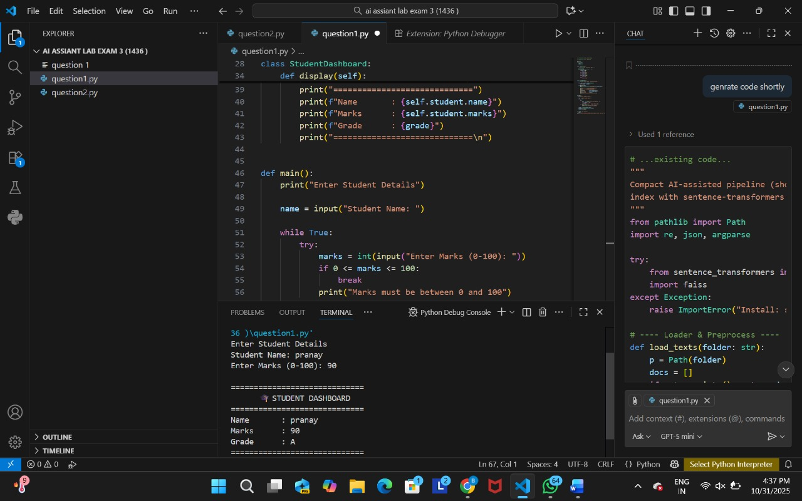

Q2:-

**Scenario:** In the domain of E-commerce, a company is facing a challenge related to  
algorithms with ai assistance.  
Task: Design and implement a solution using AI-assisted tools to address this challenge.  
Include code, explanation of AI integration, and test results.  
Deliverables: Source code, explanation, and output screenshots.

OUTPUT:-

